

REDEEM & RENEW

SKIN SOLUTIONS

**21 Scientific Studies**

**Please Note**

**Terminology: Viruses are not living organisms; they must enter a living cell to multiply. Therefore, antiviral agents (Nano Silver) are said to “inactivate” viruses, not “kill” them.**

1. **A critical first step in discovery is to admit what you don’t know.**
2. **All scientific advances come from conceding ignorance.**
3. **Observe, test, check the scientific data and compare.**
4. **Never allow your preconceptions to influence the result.**

**Remember:**

1. **Always stay skeptical**
2. **Remain rational**
3. **Gather your own evidence**
4. **Come to your own conclusions**
5. **This is the scientific method and it works**

 All the Science references in this document are established Medical Research publications. Plus Commercial one photo and illustration.

US National Library Medicine, National Institutes of Health, Researchgate.net, [pubs.acs.org](http://pubs.acs.org/), [sciencedaily.com](http://sciencedaily.com/), [phys.org](http://phys.org/)>Biology,Journal of Applied Microbiology and [sciessent.com](https://www.sciessent.com/wp-content/uploads/2020/03/Sciessent-Coronavirus-Whitepaper.pdf)

Nanomedicine Formulations for Respiratory Infections by Inhalation Delivery - Covid-19 and Beyond

<https://www.researchgate.net/publication/340270205_Nanomedicine_Formulations_for_Respiratory_Infections_by_Inhalation_Delivery_-_Covid-19_and_Beyond>

“Clinically, the treatment formulations may be most effectively applied as a first-line intervention at an early stage of respiratory infections, i.e.,  when mostly  affecting  the upper respiratory system and bronchial tree.

**For example, the formulations could be used to control local**

**outbreaks of COVID-19 via early stage home treatment.**

We note that similar NpC dosages also provide antibacterial effectiveness. The non-development of silver NpC antiviral drug treatments until now is a market failure, likely due to unclear patents environment, making such developments unattractive for big pharma companies. Unfortunately, the gap between promising academic research and market regulatory approved products has been left to be filled by “alternative medicine” charlatans – giving bad publicity to the whole field. **To overcome this market failure situation, this article also serves as a proclamation and blueprint for an open-source drug development program to realize it.** Potential development parties – academic, clinical, manufacturing, and commercial – are invited to join via the dedicated website noted in our address.”

[Toward Nanotechnology-Enabled Approaches against the](https://pubs.acs.org/doi/10.1021/acsnano.0c03697) **COVID**-**19**

[pubs.acs.org › doi › acsnano.0c03697](https://pubs.acs.org/doi/10.1021/acsnano.0c03697)

‎[Abstract](https://pubs.acs.org/doi/10.1021/acsnano.0c03697#Abstract) · ‎[COVID-19: Setting the ...](https://pubs.acs.org/doi/10.1021/acsnano.0c03697#_i3) · ‎[Emerging Nanomaterials for ...](https://pubs.acs.org/doi/10.1021/acsnano.0c03697#_i17)

Jun 10, 2020 - (32−35) **Nanotechnology**-based **approaches** should be leveraged **to** help the fight **against COVID**-**19** as well as any future **pandemics**, in a number of ways, including (i) novel vaccines and drugs, where nanomaterials can be leveraged for direct delivery of broad-spectrum antivirals and **to** support targeted therapies **to** the ...

[Silver Nanoparticles as Potential Antiviral Agents - NCBI](https://www.ncbi.nlm.nih.gov/pmc/articles/PMC6264685/)

[www.ncbi.nlm.nih.gov › pmc › articles › PMC6264685](https://www.ncbi.nlm.nih.gov/pmc/articles/PMC6264685/)

“Virus infections pose significant global health challenges. In the present scenario, nanoscale materials have emerged as novel antiviral agents for the possibilities offered by their unique chemical and physical properties. Silver nanoparticles have mainly been studied for their antimicrobial potential against bacteria, but have also proven to be active against several types of viruses including human immunodeficiency virus, hepatitis B virus, herpes simplex virus, respiratory syncytial virus, and monkeypox virus. The use of metal nanoparticles provides an interesting opportunity for novel antiviral therapies. Since metals may attack a broad range of targets in the virus there is a lower possibility to develop resistance as compared to conventional antivirals.”

[Synthesis and Application of Silver Nanoparticles (Ag NPs) for ...](https://www.ncbi.nlm.nih.gov/pmc/articles/PMC6695748/)

[www.ncbi.nlm.nih.gov › pmc › articles › PMC6695748](https://www.ncbi.nlm.nih.gov/pmc/articles/PMC6695748/)

Does silver disinfect?

“Silver is easily available and is known to have a microbicidal effect; moreover, it does not impose any adverse effects on the human body. The microbicidal effect is mainly due to silver ions, which have a wide antibacterial spectrum. Furthermore, the development of multidrug-resistant bacteria, as in the case of antibiotics, is less likely.

**Silver ions bind to halide ions, such as chloride, and precipitate; therefore, when used directly, their microbicidal activity is shortened. To overcome this issue, silver nanoparticles (Ag NPs) have been recently synthesized and frequently used as microbicidal agents that release silver ions from the particle surface. Depending on the specific surface area of the nanoparticles, silver ions are released with high efficiency. In addition to their bactericidal activity, small Ag NPs (<10 nm in diameter) affect viruses although the microbicidal effect of silver mass is weak. Because of their characteristics, Ag NPs are useful countermeasures against infectious diseases**, which constitute a major issue in the medical field. Thus, medical tools coated with Ag NPs are being developed. This review outlines the synthesis and utilization of Ag NPs in the medical field, focusing on environment-friendly synthesis and the suppression of infections in healthcare workers (HCWs).

**Keywords:** antiviral property, healthcare workers (HCWs), medical application, microbicidal property, silver nanoparticles (Ag NPs), cytotoxicity”

[How silver ions kill bacteria -- ScienceDaily](https://www.sciencedaily.com/releases/2020/04/200409140021.htm)

[www.sciencedaily.com › releases › 2020/04](https://www.sciencedaily.com/releases/2020/04/200409140021.htm)

The National Science Foundation-funded study validated the idea of investigating the dynamics of single proteins in live bacteria, said Wang, an approach that could help researchers understand the real-time responses of bacteria to silver nanoparticles, which have been proposed for fighting against so-called "superbugs" that are resistant to commonly prescribed antibiotics.

[Antibacterial Silver - NCBI - NIH](https://www.ncbi.nlm.nih.gov/pmc/articles/PMC2364932/)

[www.ncbi.nlm.nih.gov › pmc › articles › PMC2364932](https://www.ncbi.nlm.nih.gov/pmc/articles/PMC2364932/) by JL Clement - ‎1994 - ‎[Cited by 479](https://scholar.google.com/scholar?rlz=1C1GGGE_enUS611US614&sxsrf=ALeKk03RE92vynmE8Auba6ZVom682mlicw:1599493715727&biw=1536&bih=792&dpr=1.25&um=1&ie=UTF-8&lr&cites=18154931209560772748) - ‎[Related articles](https://scholar.google.com/scholar?rlz=1C1GGGE_enUS611US614&sxsrf=ALeKk03RE92vynmE8Auba6ZVom682mlicw:1599493715727&biw=1536&bih=792&dpr=1.25&um=1&ie=UTF-8&lr&q=related:jNCFA79F8_tEbM:scholar.google.com/) The antibacterial activity of silver has long been known and has found a variety of applications because its toxicity to human cells is considerably lower than to bacteria. The most widely documented uses are prophylactic treatment of burns and water disinfection. However, the mechanisms by which silver kills cells are not known. Information on resistance mechanisms is apparently contradictory and even the chemistry of Ag+ in such systems is poorly understood.

[Antimicrobial Silver in Medicinal and Consumer Applications ...](https://www.ncbi.nlm.nih.gov/pmc/articles/PMC6315945/)

[www.ncbi.nlm.nih.gov › pmc › articles › PMC6315945](https://www.ncbi.nlm.nih.gov/pmc/articles/PMC6315945/)

The use of silver to control infections was common in ancient civilizations. In recent years, this material has resurfaced as a therapeutic option due to the increasing prevalence of bacterial resistance to antimicrobials. This renewed interest has prompted researchers to investigate how the antimicrobial properties of silver might be enhanced, thus broadening the possibilities for antimicrobial applications. This review presents a compilation of patented products utilizing any forms of silver for its bactericidal actions in the decade 2007–2017. **It analyses the trends in patent applications related to different forms of silver and their use for antimicrobial purposes. Based on the retrospective view of registered patents, statements of prognosis are also presented with a view to heightening awareness of potential industrial and health care applications.**

**Keywords:** antibiotic resistance, antimicrobial activity, medicinal silver, patents, silver, silver nanoparticles, synergism

[How silver ions kill bacteria -- ScienceDaily](https://www.sciencedaily.com/releases/2020/04/200409140021.htm)

[www.sciencedaily.com › releases › 2020/04](https://www.sciencedaily.com/releases/2020/04/200409140021.htm)

Apr 9, 2020 - The **antimicrobial** properties of **silver** have been known for centuries. Now scientists are seeking to better understand how the noble metal kills …”**The researchers observed that silver ions were causing paired strands of DNA in the bacteria to separate, and the binding between the protein and the DNA to weaken.** “Then the faster dynamics of the proteins caused by silver can be understood," said Wang. "When the protein is bound to the DNA, it moves slowly together with the DNA, which is a huge molecule in the bacteria. “**In contrast, when treated with silver, the proteins fall off from the DNA, moving by themselves and thus faster."**

[Scientists seek a deeper understanding of how silver kills ..](https://phys.org/news/2018-10-scientists-deeper-silver-bacteria.html)

[phys.org › Biology › Molecular & Computational biology](https://phys.org/news/2018-10-scientists-deeper-silver-bacteria.html)

Silver has been used for centuries as an antimicrobial to kill harmful bacteria. Ancient civilizations applied the metal to open wounds. Ship captains tossed silver coins into storage barrels to keep drinking water fresh. In hospitals today, [**silver**](https://phys.org/tags/silver/) **is used in bandages to treat burn victims, destroy pathogenic microbes on catheters, and combat dangerous "superbugs" that have grown resistant to traditional antibiotic drugs**.But the [molecular mechanisms](https://phys.org/tags/molecular+mechanisms/) of how silver kills [bacteria](https://phys.org/tags/bacteria/), and how resistance to silver develops in these microorganisms, are not fully understood. Now a new study, led by Faculty of Science biological scientists at the University of Calgary, helps enhance understanding of silver's [antibacterial properties](https://phys.org/tags/antibacterial+properties/).

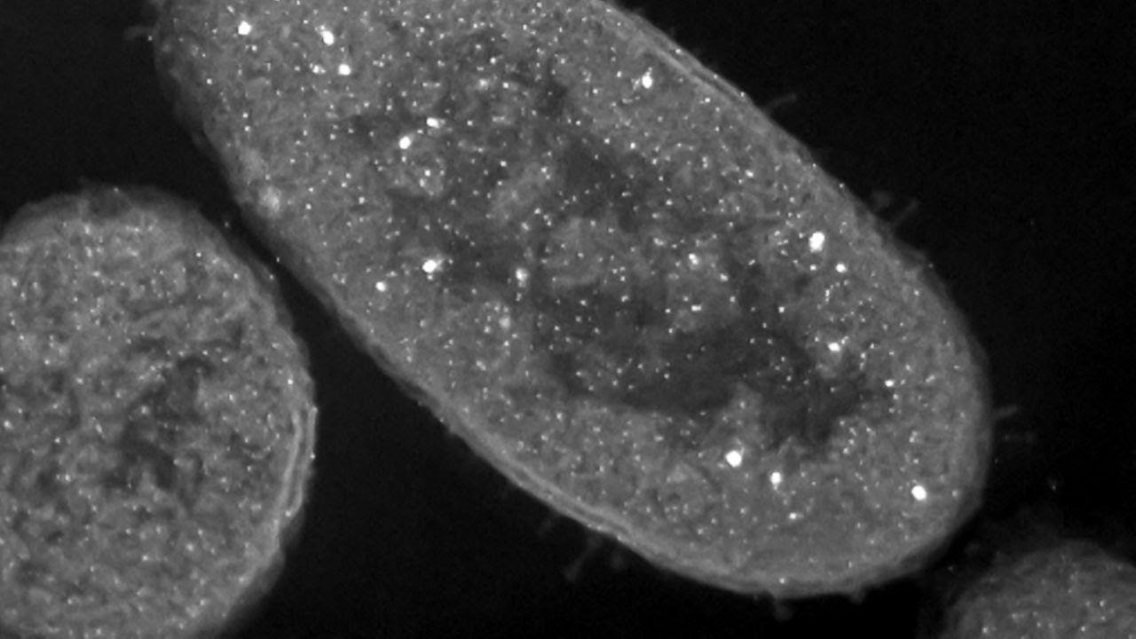Bacteria killed by silver store it in their cells, making them deadly to other bacteria. **Silver nanoparticles are visible inside the bacteria as white spots.** RACHELI BEN-KNAZ WAKSHLAK, RAMI PEDAHZUR, AND DAVID AVNIR

Silver turns bacteria into deadly zombie

The zombie apocalypse may be more than just a horror story for some bacteria. New research shows that when exposed to a microbe-slaying silver solution, the germs can “go zombie,” wiping out their living compatriots even after death. The results may explain silver's long-lasting antibacterial power and could improve the performance of medical products that keep us safe from harmful pathogens.

[Silver. A powerful weapon against microbes - Corporate](https://www.coloplast.com/products/wound/articles/silver-a-powerful-weapon-against-microbes/)

[www.coloplast.com › products › wound › articles › silver-a-powerful-...](https://www.coloplast.com/products/wound/articles/silver-a-powerful-weapon-against-microbes/)

“Silver has a long history of use in wound care and the safety record of the modern silver-containing wound dressings has been excellent. **Several mechanisms exist by which the body removes excess silver. These mechanisms include natural tissue turnover that occurs particularly in the epidermis,and the host metal detoxification mechanisms involving metallothioneins and glutathione occurring in the liver and kidney, where the silver is excreted ultimately in faeces and urine.” Silver** is a well-documented **antimicrobial that** has been shown to kill bacteria, fungi and certain viruses. It is the positively charged **silver** ions (Ag+) that possess ...

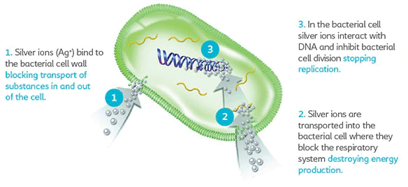

[Agion Antimicrobial Efficacy Against Coronavirus ... - Sciessent](https://www.sciessent.com/wp-content/uploads/2020/03/Sciessent-Coronavirus-Whitepaper.pdf)

[**www.sciessent.com › wp-content › uploads › 2020/03 › Sciessent-Cor…**](https://www.sciessent.com/wp-content/uploads/2020/03/Sciessent-Coronavirus-Whitepaper.pdf)

The **Agion antimicrobial** coating inhibits the growth of bacteria, molds, fungi and other microbes through the release of silver (Ag) ions. The controlled release of silver ions provides continuous **antimicrobial** protection for the product for the life of the coating.

* Test Results Chinese CDC (2003) • Complete inactivation of SARS coronavirus in 2 hours •
* VERO E6 cell substrate, using virus CPE method University of Arizona (2004) •
* 90% reduction of human coronavirus 229E in 1 hour • 99% reduction of human coronavirus 229E in 2 hours
* 99.999% reduction of human coronavirus 229E in 24 hours • TCID50 technique, monitoring MRC-5 cell monolayers for cytopathic effects

[Revisiting the antiviral properties of silver – Applied Silver](https://www.appliedsilver.com/revisiting-the-antiviral-properties-of-silver/)

[www.appliedsilver.com › revisiting-the-antiviral-properties-of-silver](https://www.appliedsilver.com/revisiting-the-antiviral-properties-of-silver/)

No stone is being left unturned in the race to unravel the complexities of the novel coronavirus. Just as researchers are experimenting with existing drugs as clinical treatment for pandemic patients, proven antimicrobials and antivirals are being revisited for potential application against SARS-CoV-2, the virus that causes COVID-19. Silver is one such well-documented method for extinguishing bacteria, mold, mildew and viruses.

**Following are 8 additional key peer-reviewed studies that support why silver is also effective as an antiviral.**

**Antiviral Effects technology** is based on the powerful broad-based antimicrobial capabilities of silver ions. Silver exhibits killing properties against bacteria, mold, mildew and viruses that is well-documented in literature. It has been understood for centuries that silver is an effective antimicrobial. In recent years, scientists and clinicians have specifically studied the impact of silver on viruses.

 1) Silver nanoparticles prevent coronaviruses from infecting mammalian cells in vitro. Key scientific finding: Silver nanoparticles inhibit viral entry into hosts cells, therefore preventing virus-mediated infection. Reference: **Inhibitory effect of silver nanomaterials on transmissible virus-induced host cell infections. Biomaterials (2014): 35; 4195-4203**

2) Silver is effective against enveloped and non-enveloped viruses. Key scientific finding: Silver inactivates enveloped viruses (e.g. coronaviruses) through a charge based interaction with their outer lipid envelope layer. Silver inactivates non-enveloped viruses through formation of bonds with sulfur groups on key proteins. Reference: Antiviral Activity of Graphene– **Silver Nanocomposites against Non-Enveloped and Enveloped Viruses. Int. J. Environ. Res. Public Health 2016,13, 430**

**3)** Disinfectants containing silver inactivate the hard-to-kill norovirus within 30 mins. Key scientific finding: Exposure of norovirus to silver citrate results in physical (morphological) changes in norovirus within 30 mins, similar to observations with heat, high pressure and copper. Reference: Efficacy of a disinfectant containing silver dihydrogen citrate against GI.6 and GII.4 human norovirus. **Journal of Applied Microbiology, 2016, 122, 78—86.**

**4)** Silver ions containing powders kill human and cat coronaviruses. Key scientific finding: Zeolites containing silver and silver/copper caused significant reductions of coronavirus 229E after 1 h in suspension. **Reference: Assessment of the Antiviral Properties of Zeolites Containing Metal Ions. Food Environ Virol (2009) 1:37–41**

**5)** Silver ions inactivate the flu virus. Key scientific findings: Silver selectively inactivates key enzyme neuraminidase through formation of a disulfide bond, impairing the ability of the flu virus to cause an infection. **Reference: Comparison of the Antiviral Effect of Solid-State Copper and Silver Compounds. J Hazard Mater. 2016 Jul 15; 312:1-7.**

**6)** Silver ions used to contain viral infections in honeybee populations. Key scientific finding: Silver based treatment doubles the survival rates of honeybees infected with Sacbrood virus**. Reference: Efficacy of silver ions against Sacbrood virus infection in the Eastern honeybee Apis cerana. J Vet Sci 2015, 16(3), 289-295**

**7)** Silver is a gentle and powerful broad-spectrum antimicrobial. Key scientific findings: Review article describing silver antimicrobial and antiviral activities against a variety of pathogens. **Reference: Inhibitory Antimicrobial silver: an unprecedented anionic effect. Sci Rep. 2014 Nov 24;4:7161.**

**8)** Silver coating is used to kill HIV and many other viruses. Key scientific findings: Over 90% reduction in viral titers were observed within 4 hours of exposure to silver for HIV, influenza, herpes simplex and dengue viruses. **Reference: Protective Hybrid Coating Containing Silver, Copper and Zinc Cations Effective Against Human Immunodeficiency Virus and Other Enveloped Viruses. BMC Microbiol. 2016 Apr 1;16**

**An Educated Conclusion**

Nanotechnology in Medicine - Nanoparticles in Medicine

[https://www.understandingnano.com/medicine.html#](https://www.understandingnano.com/medicine.html):

**The use of nanotechnology in medicine offers some exciting possibilities. Some techniques are only imagined, while others are at various stages of testing, or actually being used today.**

**Nanotechnology in medicine involves applications of nanoparticles currently under development, as well as longer range research that involves the use of manufactured nano-robots to make repairs at the cellular level (sometimes referred to as *nanomedicine*).**

**Whatever you call it, the use of nanotechnology in the field of medicine could revolutionize the way we detect and treat damage to the human body and disease in the future, and many techniques only imagined a few years ago are making remarkable progress towards becoming realities.**

PURE HEALTH FOR YOUR BODY & HOME